**BSC2005 Exam #4 Study Guide**

In general, material from the book (and other readings), material from the lecture videos and other videos, and material from the assignments (especially those which reinforce a concept from the reading and/or lectures) is all fair game for the exam.

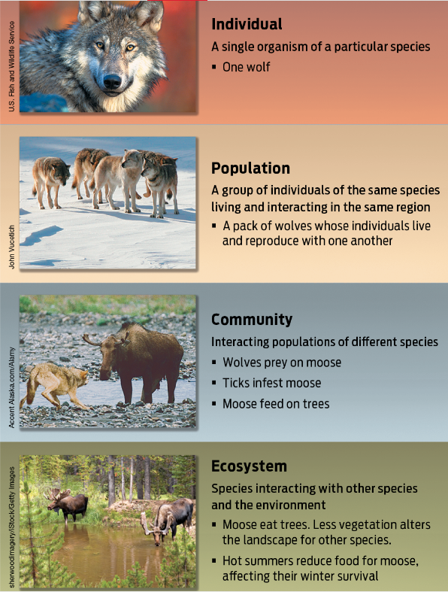This is not an exhaustive list of everything you may need to know, and not every single thing from this list will necessarily be asked about on the exam, but this study guide is meant to help you focus in your studying effort on the most important concepts from the modules covered by this exam.

**Module 13: Population Ecology**

* What is ecology? What are the various levels at which someone could study ecology?
  + The study of the interactions among organisms and between organisms and their non-living environment
* What is the definition of a population? How would we determine if two individuals are from the same or different populations?
  + A group of interbreeding organisms of the same species living and interacting in a particular area
  + Must be same species
  + Must interact regularly
* Community:
  + A group of interacting populations of different species living in the same area
* Ecosystem:
  + All living organisms in an area and the nonliving components of the environment with which they interact
* What are the three types of potential population distributions / dispersion patterns? Be able to identify examples of each.
  + 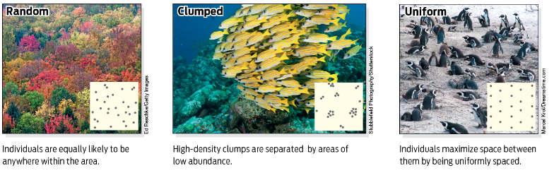Random, clumped, uniform. Few species fall strictly into one category
* Growth rate:
  + Birth rate – death rate
* What factors increase population size? What factors decrease population size?
  + Increase: immigration, births
  + Decrease: emigration, deaths
* What does an exponential growth curve look like for a population? *Why* does it look like this?
  + Y=x^2, it is unrestricted and the populations grows a certain percentage every generation
* Do we see exponential growth in real populations? Under what conditions? Why aren’t they more common?
  + Rarely, bacterial growth can be exponential. Unusual because resources are limited and the environment has a carry capacity. Also humans
  + Occurs with abundant food, no reproductive constraints, no predators
* What does a logistic growth curve look like for a population? *Why* does it look like this?
  + TanH, fast growth, then level off near carrying capacity. Harder to grow with more competition for resources
* What is the carrying capacity? What happens if a population exceeds its carrying capacity?
  + 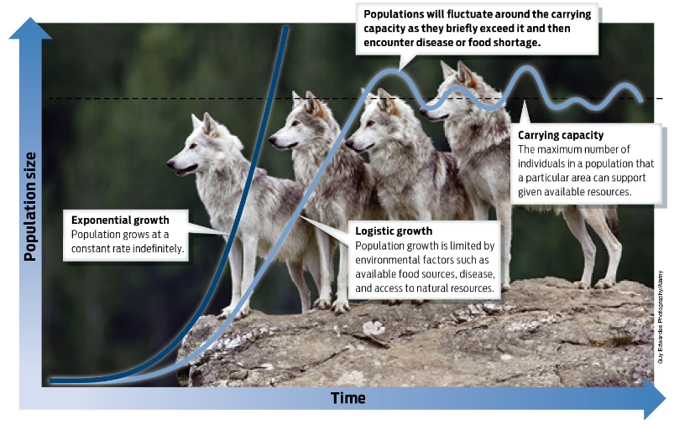The maximum populations size that a given environment or habitat can support given its food supply and other natural resources
  + As the population reaches the carrying capacity, the population will fluctuate around the carrying capacity
* Be able to distinguish between abiotic factors and biotic factors that affect population size or distribution, and give examples of each.
* What is dispersal, and what role does it play in population distributions?
  + Behavior which changes a species distribution over time
  + Individuals move from birth site to breeding site, or from breeding site to breeding site
* Are abiotic or biotic factors more likely to depend on the starting density of the population? Why? How does density wind up influencing population size?
  + biotic factors are more likely as they are more likely to be density dependent
  + Lack of food can make a population more susceptible to predation
  + Disease propagates more quickly through dense populations
  + Large groups can better defend from predators
* How can density-dependent factors lead to population cycles?
  + A factor whose influence on population size and growth depends on the number and crowding of individuals in the population
  + Biotic factor
  + Predation, food, disease, waste accumulation, competition
* Density-independent:
  + A factor that can influence population size and growth regardless of the numbers and crowding withing a population
  + Abiotic factor
  + 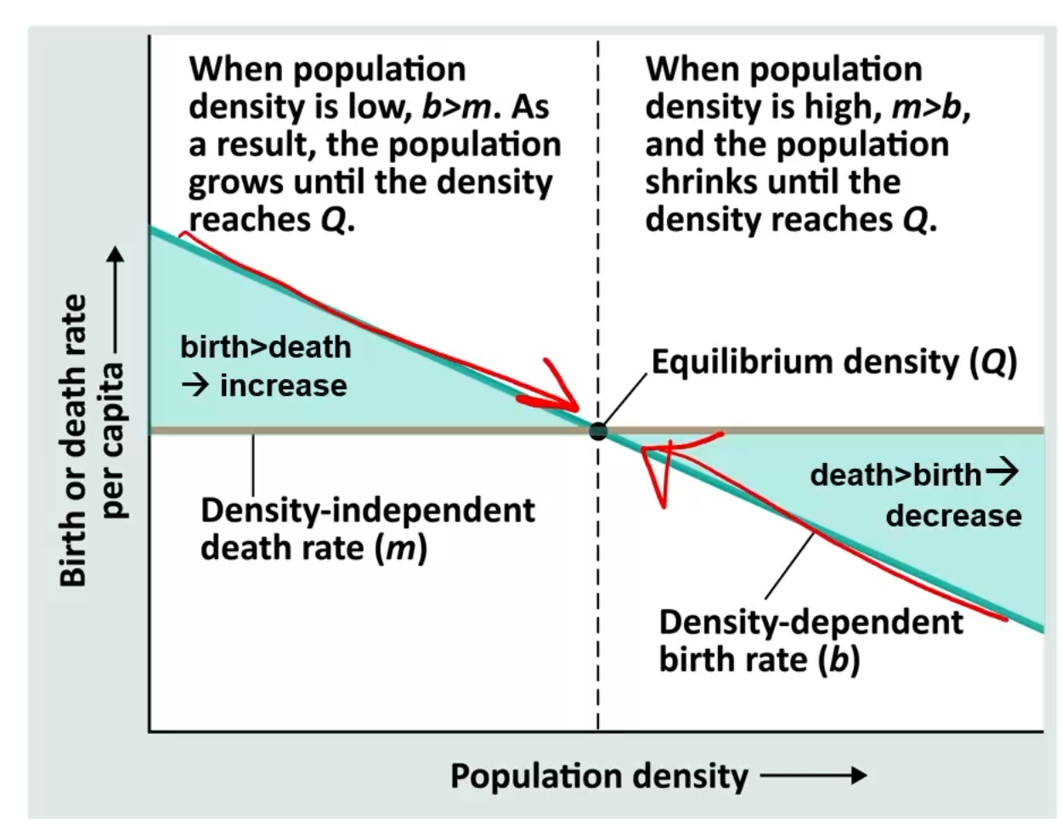Weather, temperature, precipitation, fire
* 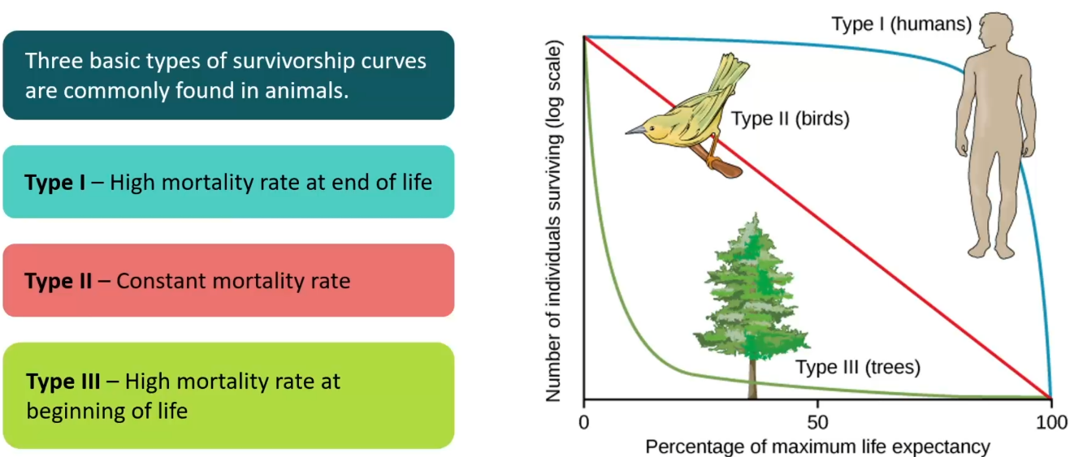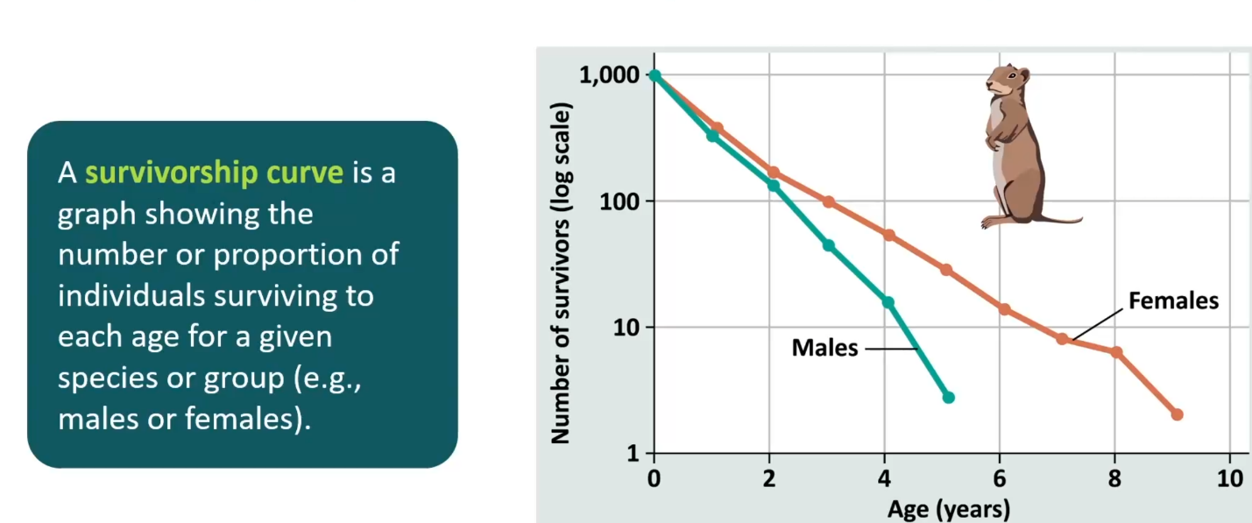What is a survivorship curve? What are the three types of survivorship curve? Give some examples of species that would have each type.
  + Type 1: small number of offspring, parental care
  + Type 2: middle ground
  + Type 3: high number of offspring, no parental care
* 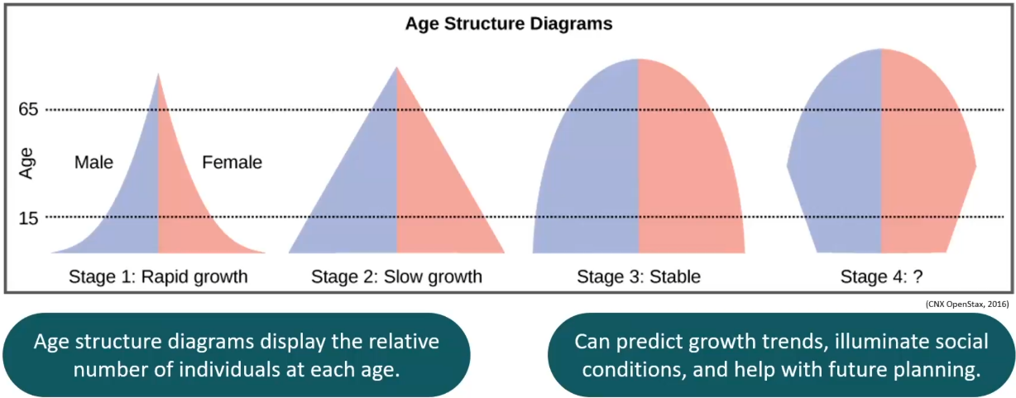Be able to interpret a population age-structure diagram, and make predictions about what will happen to population size over time.

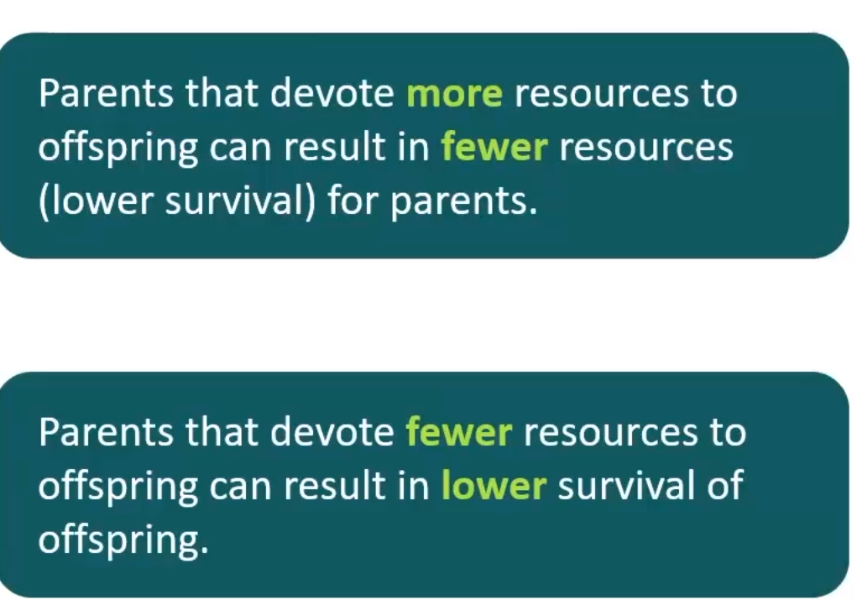

* What are the differences between r-selected and K-selected species? Which ones would you expect to have more parental care? Which ones would have which type of survivorship curve?
  + K selected species are density dependent. More competition near K (carrying capacity), traits that enhance survival and parental care are selected. Typically large, mature late, and are type-1 or 2, iteroparous
  + 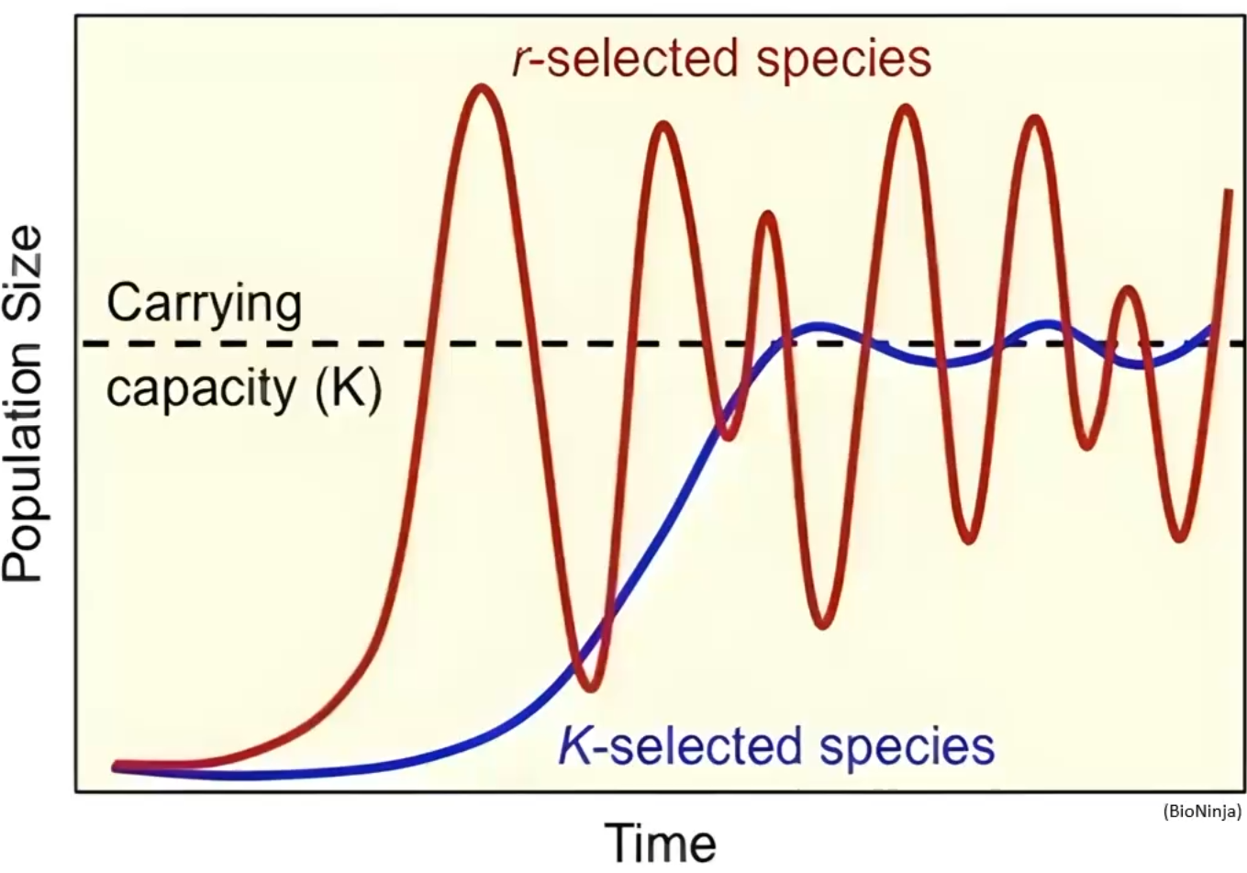R-selected species are density independent. Maximize reproductive output. Typically small, high numbers of offspring, mature early, short life, type-3 survival, semelparous
* Iteroparous vs semelparous
  + Iteroparous: reproduce multiple times in lifetime
  + Semelparous: reproduce once in lifetime

**Module 14: Community Ecology**

* What are the different trophic levels of a food chain?
  + Producers: autotrophs, plants, algae
  + Consumers: heterotrophs
  + 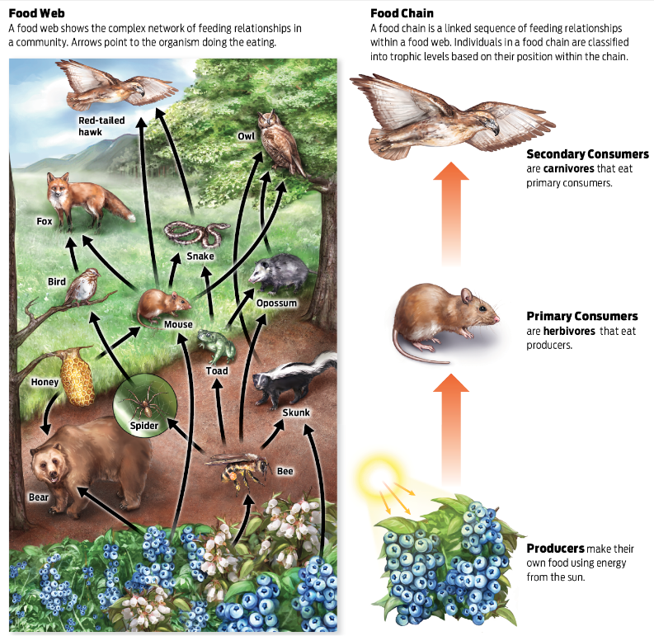Primary consumers: herbivores
  + Secondary consumers: carnivores that eat herbivores
* How much energy is transferred from one trophic level to the next? What happens to the rest?
  + 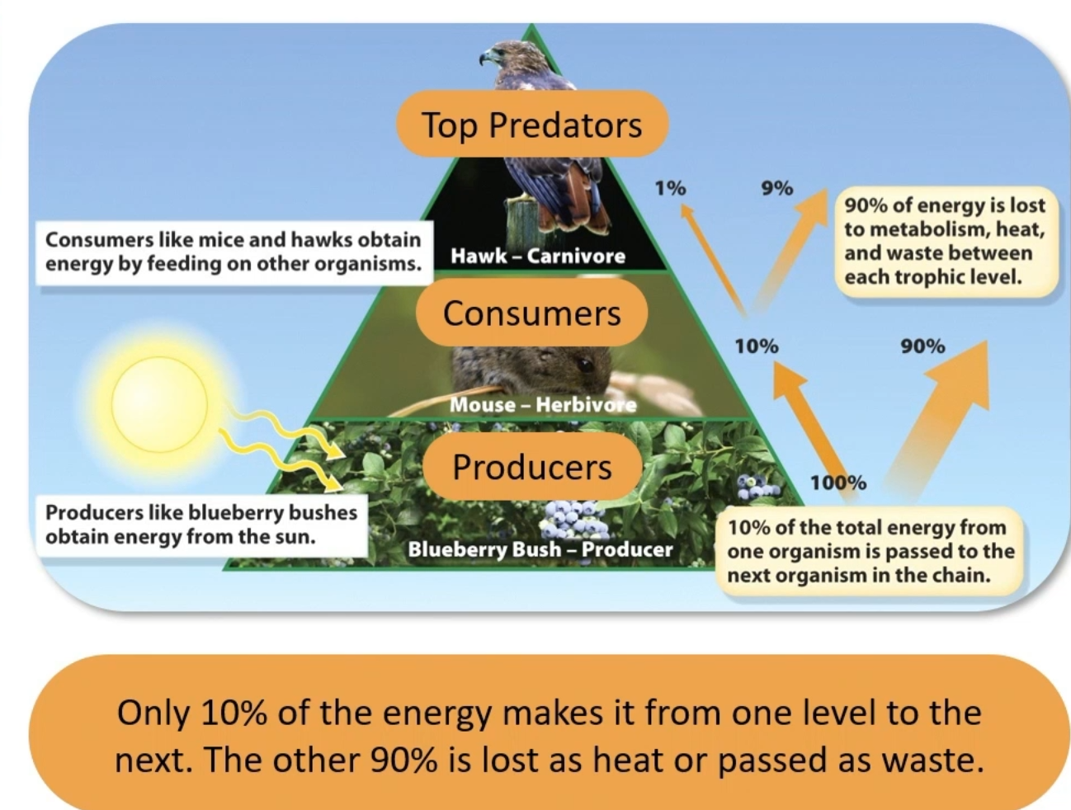10%. Rest is lost to waste or metabolic processes
* What’s the difference between a food chain and a food web?
  + Food chain: a linked series of feeding relationships in a community in which organisms further up the chain feed on the ones below
  + Food web: A complex interconnected set of feeding relationships in a community
* What’s a niche?
  + The space, environmental conditions, and resources that a species needs to survive and reproduce
  + A particular species slice of the ecosystem pie
  + Niches are how a species interacts with the environment
* What is the difference between generalists and specialists?
  + Generalists: an organism that can be successful in a variety of environments, often because of a varied diet
  + Specialists: an organism that requires a specific resource or habitat to be successful
* Competition:
  + An interaction between two or more organism that rely on a common resource that is not available in sufficient quantities
* What’s the competitive exclusion principle and what are its possible outcomes?
  + When two species compete for resources in an identical niche, one in inevitably eliminated from that niche
  + The better adapted species pushes out the lesser adapted species
  + 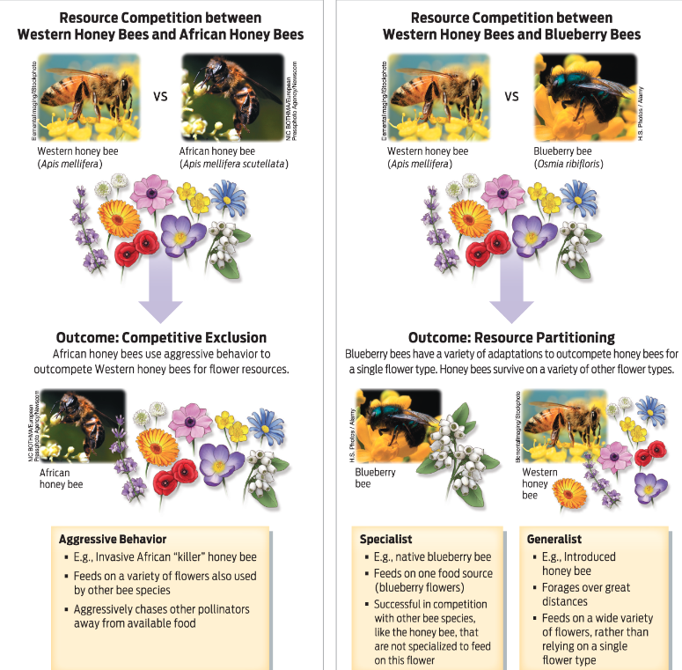Pushes other species to specialization (resource partitioning) or extinction (competitive exclusion)
* Resource partitioning:
  + The use of different resources by different species in a given area, enabling them to divide a niche
* What is character displacement?
  + Two species in competition will both evolve shifts in resource use so that competition is reduced or eliminated
  + Peaceful compromise
* What are invasive species? How do they differ from introduced species? How does understanding population ecology and community ecology help us manage them?
  + Invasive species
    - Lack natural predators and compete with native species for food and other resources, act like r-selected species
    - Threat to community structure, can lead to extinction of native species
  + Introduced species
    - Species that are not native to a particular environment and that have arrived as a result of human activity
* Bio control:
  + Bring the predators of invasive species from their home habitat into the invaded habitat, counters predator escape
* What are ecosystem services?
  + Things an ecosystem does that are beneficial to humans
  + 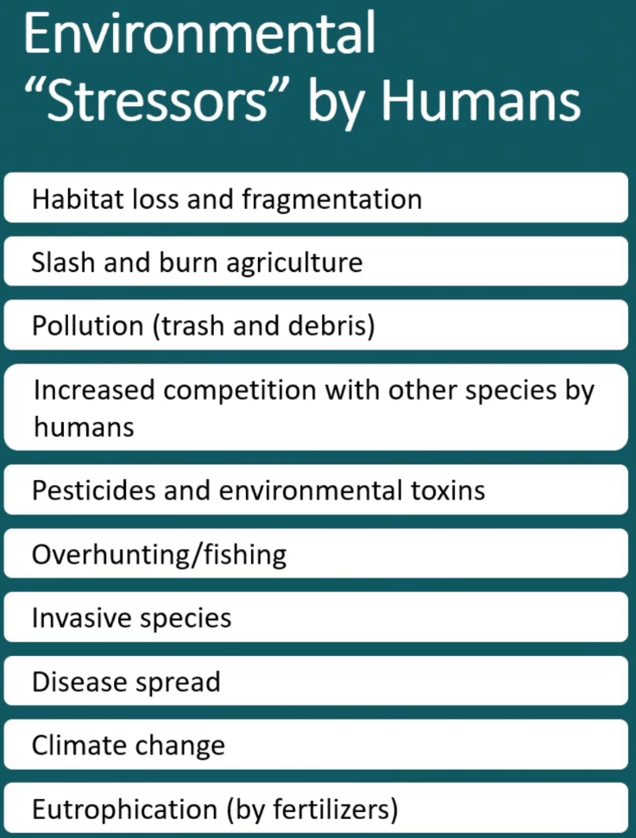Water purification,
* What is biomagnification and why is it a problem?
  + Concentration of pollution increases going up the food chain
  + Predators have a higher concentration of pollutants than what they eat
* Environmental stressors:
* What types of interactions can happen between species within a community.
  + Predator/prey
  + Competition
  + Symbiosis
* Be able to identify the different types of symbioses and give examples of each.
  + Parasitism: one benefits, one loses. Ticks
  + Mutualism: mutually beneficial, bees + flowers
  + Commensalism: one benefits, one get no effect. Birds that follow large mammals to eat the bugs they stir up
* How does symbiosis lead to co-evolution between two species? Is this more or less likely under particular types of symbiosis?
  + Changes in one species will lead to selection on the other species
  + Arms-race in parasitic relationships
  + Mutualisms can lead to obligate symbiosis, neither can survive without the other, so changes in one must be followed by changes in the other
* What is a keystone species? What role do they play in their community?
  + A species that has a disproportionately large effect on the other species in its environment
  + Central role in the community, indicator of the health of the ecosystem
  + Reduction in the population of keystone species can have large, negative effects on the ecosystem
* What are the male vs. the female parts of angiosperm flowers? How does sperm reach the egg? What are some ways pollen reaches the female parts of the flower?
  + 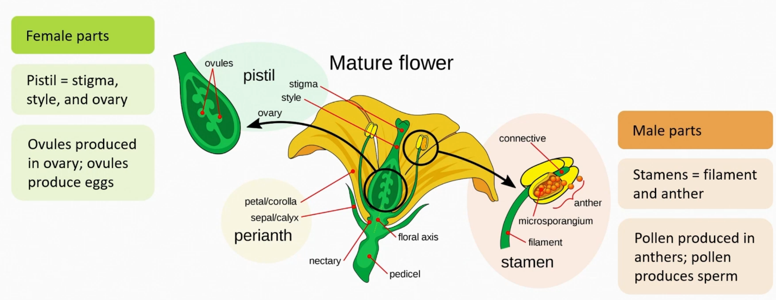Male and female parts may be on same or different flowers
* If you eat an apple, which parts correspond to which parts of the flower?
  + 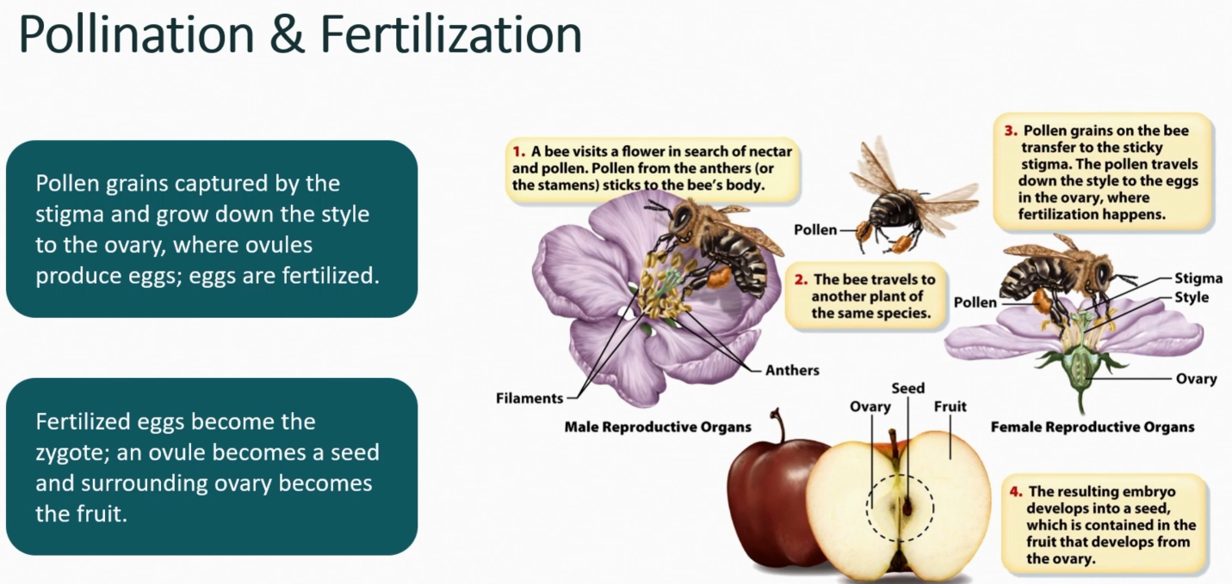Ovary is the fruity flesh
* Why are pollinators frequently considered to be keystone species? What would happen if they were removed?
  + Pollinators are essential for the reproduction of angiosperms
  + Without pollinators, the angiosperms, the primary producers in many/most ecosystems, will be unable to reproduce and will die off, killing the existing ecosystem

**Module 15: Ecosystem Ecology & Sustainability**

* What is an ecosystem? How does it differ from a habitat? From a biome?
  + Ecosystem: living and non-living components of an environment, including the organisms present (biotic factors) and the physical and chemical environment with which they interact (abiotic factors)
  + Ecosystems are constantly adjusting to the small changes in the communities
  + Habitat: the physical environment where a specific organism lives and which it is adapted
  + Biome: a large geographic area defined by characteristic plant life, which is determined by temperature and moisture levels
* 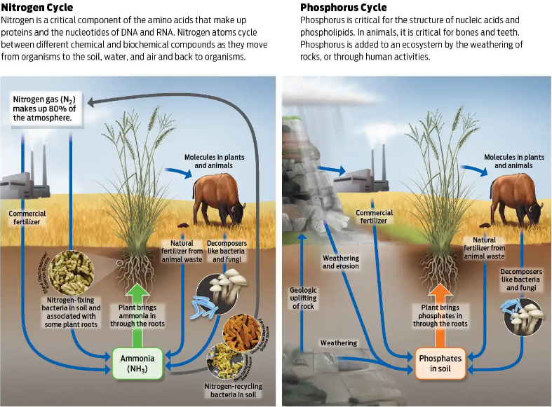Nutrient cycles
* For each of the following terrestrial biomes, be able to make generalizations about the places you will find it, what its typical temperature and rainfall, and plant/animal composition: tundra, desert, grasslands, taiga, temperate deciduous forests, tropical forests, Mediterranean.
  + Tundra: coldest biome, nutrient poor, low-growing vegetation, permafrost close to the surface, low biotic diversity. Far north and mountain tops
  + Desert: 20% of earth’s surface, characterized by lack of rainfall, not temperature. Antarctica is a desert. Many well-adapted small vertebrates and insects, nutrient rich soil, waits for rain
  + Grasslands: prairies, grasslands, savannah, steppes. Few trees, mostly perennial grasses and other non-woody plants. Many large herbivore grazers with their associated predators. Large and small vertebrates and invertebrates
  + Forests in general: cover 1/3 of earth’s land area and hold 70% of carbon
  + Taiga: Coniferous forests, evergreens. Long, cold winters, short summers. Nutrient-poor soil. Migratory animals. Lots of animals
  + Temperate deciduous forests: Defined seasons. Fertile soil, high plant/animal diversity. Long growing seasons
  + Tropical forests: Equatorial, warm, lots of rain. Two seasons (dry and wet). Highest biological diversity, poor soil (all nutrients are above soil)
  + Mediterranean: Long, hot, dry summers. Cool, damp winters. Short evergreen trees and shrubs with leathery leaves
  + 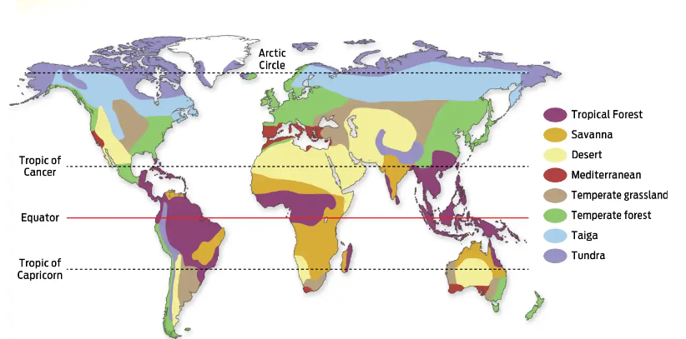Savana: warm temperatures, dry and rainy seasons. Primary grasses with shrubs and trees
* 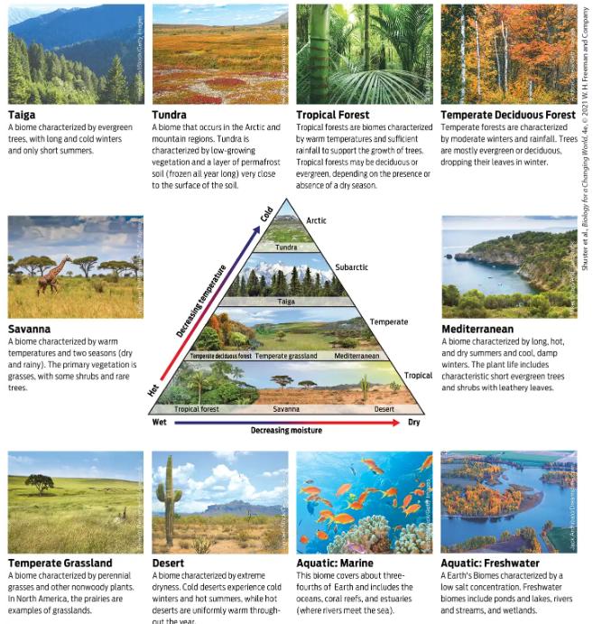What types of marine biomes are there, and why are they important? What about freshwater biomes?
  + Marine: saltwater, includes mixed fresh/salt water areas. Evaporation produces rain. Lots of algae which produce atmospheric O2
  + Freshwater: ponds, lakes, rivers, steams, wetlands. Low salt concentration (<1%). Tremendous diversity of plants and animals
* What’s the difference between weather and climate?
  + Weather: Day to day shifts in temperature and precipitation
  + Climate: Long-term regional averages
* What is the evidence that the global temperature has increased over time?
  + Average global temperature has increased
  + The rate of the increase has increased
* What is Arctic amplification and why is it important? What has happened to sea ice levels over time?
  + The artic warms up about 2x as fast as the rest of the world
  + Sea ice levels have decreased over time
  + Positive feedback cycle, warming causes more warming due to being less reflective
* How does a changing climate affect populations/communities of plants and animals?
  + Rising sea levels
  + Changing patterns of precipitation
  + More extreme weather events
  + Seasons may begin sooner or end earlier
  + Plants may bloom at different times
  + Animals will shift their ranges or go extinct
  + 1M species at risk, 15-40% of plants/animals
* What happens if a species can’t adapt to the changing climate?
  + Go extinct
* What are greenhouse gasses and how do they affect climate change?
  + 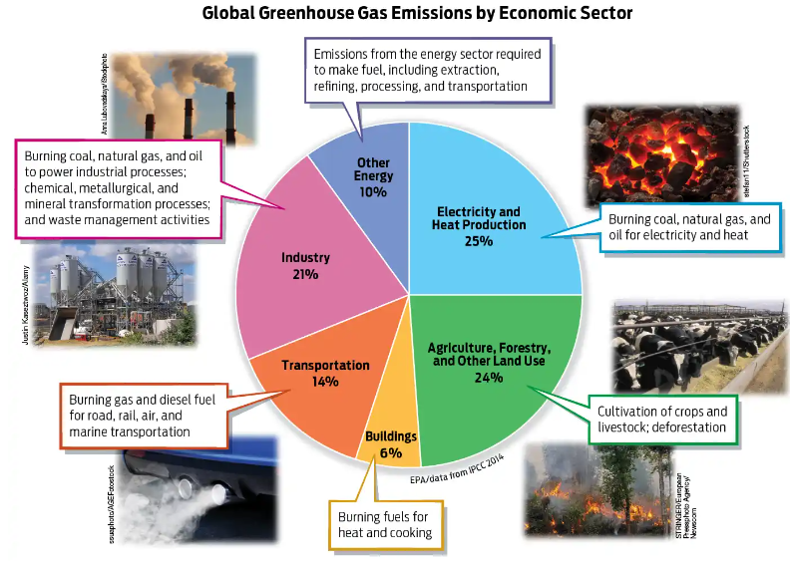Gases that reflect radiated heat back to the surface
* What is the carbon cycle? Where does atmospheric carbon come from? Where does it go to? How do human activities affect this?
  + 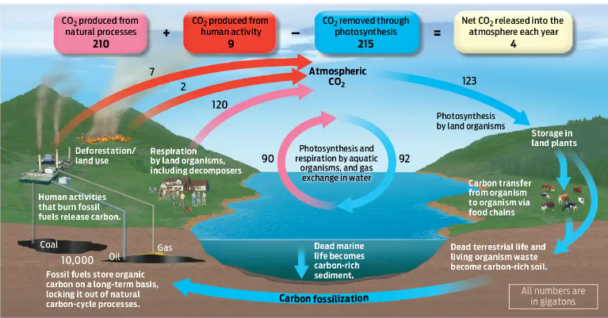Atmospheric carbon being sequestered in soil/plants/fossil fuels, which are then released again into the atmosphere
* What is the relationship between atmospheric carbon and global temperature?
  + Higher CO2 increases greenhouse effect, increasing temperature
* What is the role of methane in global warming? Where does the methane mostly come from? (Hint: think back to Module 11)
  + Green house gas, worse than CO2. Cow farts, methane producing bacteria
* What is sustainability?
  + The use of earth’s resources in a way that will not permanently destroy or deplete them, living within the limits of the earths biocapacity
  + Comprises three interdependent areas:
  + Ecological preservation: conserving natural resources
  + Economic viability: efforts can be supported on a continuing basis
  + Social justice: everyone can access
* What does the human population growth curve look like? What about carrying capacity?
  + Exponential
  + Carrying capacity is unchanged, before accounting before technological progress
* What is an ecological footprint? What factors affect it? What factor contributes the most to the global footprint?
  + Measure of how much land and water area is required to supply the resources a person/populations consumes, and to absorb the wastes it produces
  + Measured in global hectares per use, sustainable is 1.6 ha, actual use is 3.17
  + Accounts for land needed to produce food, amount of fresh water needed to drink, plants needed to consume waste CO2 from breathing and energy production, resources required to produce goods consumed, energy production
* What is overshoot? How much do we overshoot in a given year?
  + Global consumption exceeds sustainable biocapacity. We consumer 1.7 earths every year
* What is the water cycle? Where does liquid water come from? Where does it go to?
  + 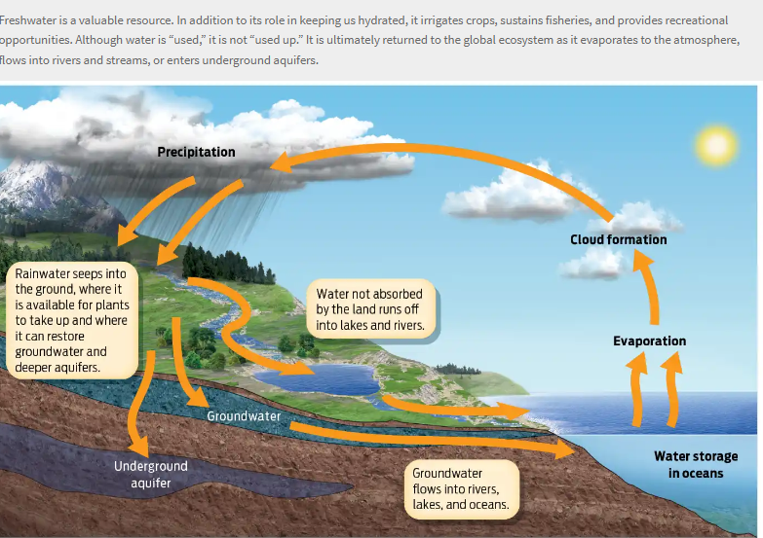The continuous movement of water on, above, and below the earth’s surface
* What is the role of water in sustainability? How is most water used? Why is available water so limited?
  + Water is a renewable resources, but only 1% of total water is available for human consumption
  + 90% of water is used for agriculture
  + Water use increases with trophic level
  + Most water is saltwater, water is not distributed equally
* Phenology:
  + The study of cyclic life events such as plant flowering and animal migration and how these are influenced by climate and seasonal changes